1.

**select ename**

**from employees**

**where empno in (select mgrno**

**from employees group by mgrno having count(empno)=(**

**select count(empno) from employees group by mgrno order by count(empno) desc limit 1));**

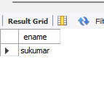

**2.**

**select a.ename**

**from employees a**

**where a.sal> (select avg(e.sal)**

**from employees e**

**where e.mgrno=a.empno group by e.mgrno);**

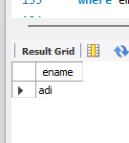

**3**

**.select ename from employees**

**where empno in (select mgrno from employees group by mgrno**

**having count(empno)=(select count(empno) from employees group by mgrno order by count(empno) desc limit 2,1));**

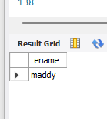

**4.**

**select * from employees**

**where empno in( select empno from incentives**

**where incentive_date between '2019-01-01' and '2019-12-31'**

**and incentive_amount=(select max(incentive_amount) from incentives where incentive_date between '2019-01-01' and '2019-12-31'));**

